# Chronic kidney disease prediction using Watson Auto AI

PROJECT DOCUMENTATION

RSIP CAREER BASIC ML 070

V. ARTHI

arthivenkatachalam2018@gmail.com

# INDEX

INTRODUCTION

1. Overview
2. Purpose

2. LITERATURE SURVEY

1. Existing problem
2. Proposed solution

3. THEORETICAL ANALYSIS

1. Block diagram
2. Hardware / Software designing
3. EXPERIMENTAL INVESTIGATION
4. FLOW CHART
5. RESULT
6. ADVANTAGES & DISADVANTAGES
7. APPLICATION
8. CONCLUSION

10.FUTURE SCOPE

11.BIBLIOGRAPHY

APPENDIX

A. Source code

# INTRODUCTION

Overview

The Project "Chronic kidney disease prediction using Watson Auto AI" predicts that if a person has Chronic kidney disease so that the patient can be treated. The project is based on IBM provided features. It consist of Watson studio Auto AI experment whic uses different pipelines and uses the best one.The prediction is shown using Node Red app dashboard.

The Chronic kideney disease condition depends on many factors such as BP, Sugar, other health condition. An Auto AI Experiment consider these parameters and apply best machine learning algorithm to get result process of getting the prediction if a person is having the diseases consist of authentication which uses servies credentials after the whole process the person can better treatment. thus machine learning algorithm can help in medical department

# PURPOSE

In Health Sector hospitals has to give treatment for the people, having information if a person might have that diseases will be a help for the doctors so they can give treatment accordingly so machine learning can be a tool for the future

Today, machine learning is helping to streamline administrative processes in hospitals, map and treat infectious diseases and personalize medical treatments. ... “It can also be used to demonstrate and educate patients on potential disease pathways and outcomes given different treatments.

# LITERATURE SURVEY

Existing problem

In society their are many health related problems in some of these problems time is key if a person is ducted with that disease in the early stage he can be cured but if the disease for some reason has not been detected then the person may die because of that disease Proposed Solution

if we use machine learning then we can predict if a person may get the diseases in future then we can give treatment accordingly by the help of machine learning we can save lives of the people

# THEORETICAL ANALYSIS

Block Diagram

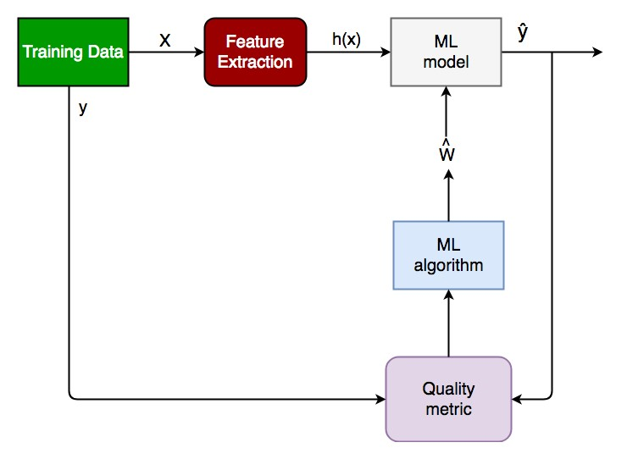

In Machine Learning according to these steps machine can predict the result also one more benefit is that when a large data is present, its not possible for a human to analysis the huge data. So, its preferable that a machine uses algorithms to analysis these data and predict the future data which can help in different ways.

The project uses Watson Auto AI Experiment Service.The project used XGB

Classifier Algorithm to predict if the person has kidney disease Auto AI Experiment implements 8 different pipeline and uses the best one. Also, a cloud object storage service needed to store the dataset and machine learning service instance. Node Red App service is required to getauthen ca on easily and get predicted kidney disease NodeRed Dashboard or building UI Applicon.

HARDWARE/SOFTWARE

This project can be implemented using IBM CloudServices on a PC. A machine learning service have to create and also a Watson studio, cloud storage service instance to store dataset. A Jupyter notebook can be added to project & we have to write code to get authencated which include geng API key , instance ID,pre token etc.

Experimental Invesgation

There are six steps in experimental investgation of a general project:

1. Choose a Project Idea
2. Conduct Background Research
3. Compose a Hypothesis
4. Design your Experiment
5. Collect Data

6.Analyse Data and Draw Conclusions

# FLOW CHART

Chronic kidney disease prediction flow chart

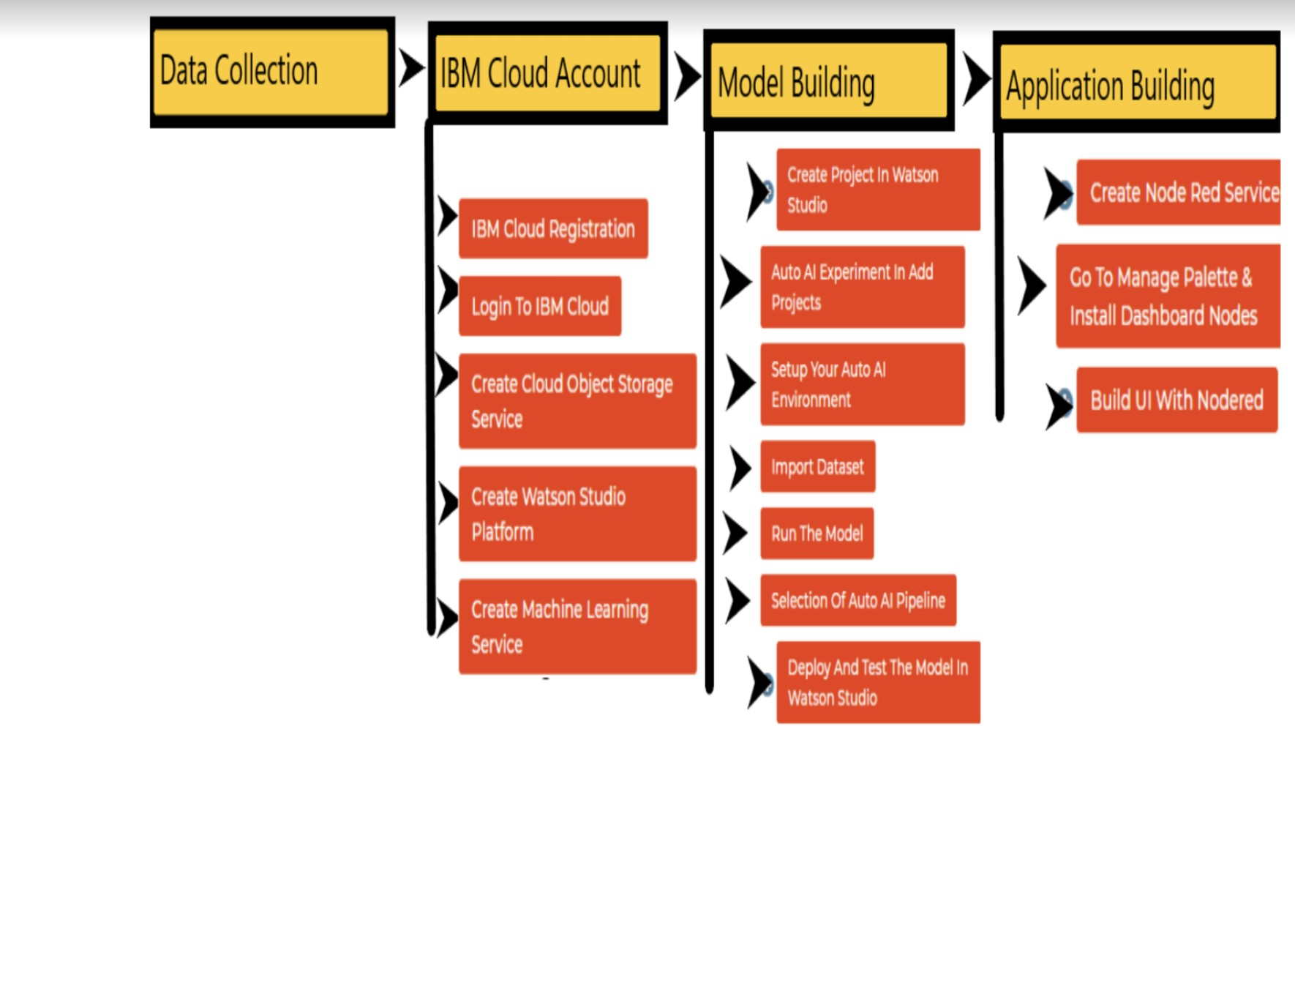

# Result

After the implementation of the project the ui predicts at he or she was affected by the chronic kidney disease. The Node Red UI provide us simple way to get the result of Auto AI Experiment. The Node Red User Interface can be a web application help the people to be aware of the health situation

Here is the node red UI which predicts chronic kidney disease

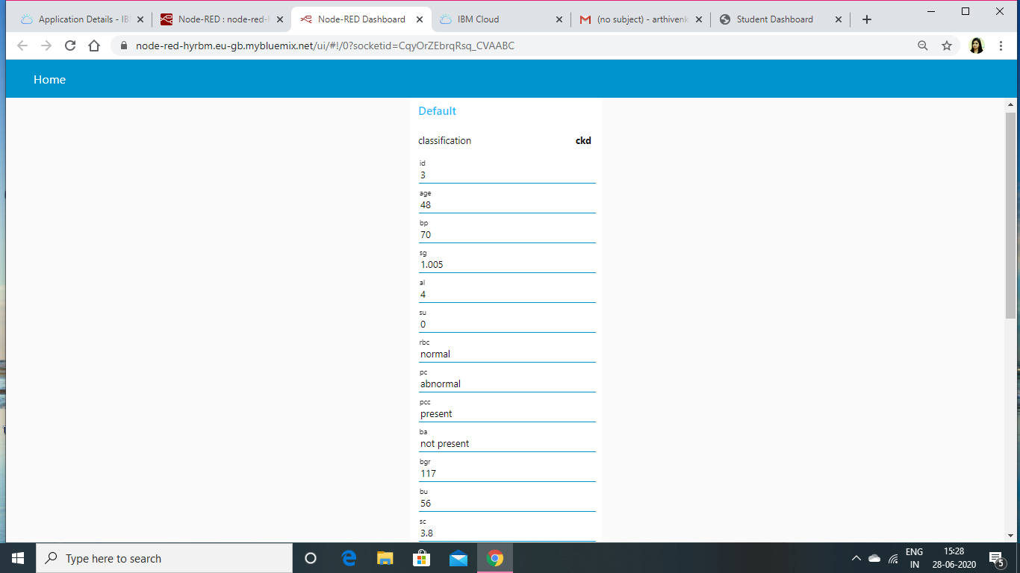

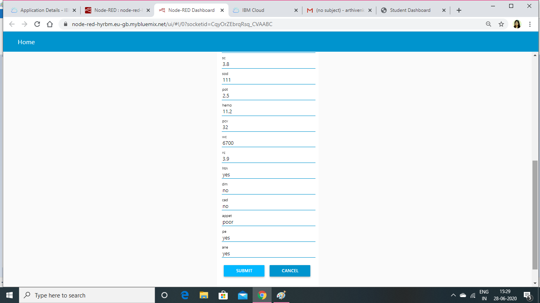

# Advantages and Disadvantages

|  |  |
| --- | --- |
| Advantages | Disadvantages |
| Handling multi-dimensional and multi-variety data | Machine Learning requires massive data sets to train on, and these should be unbiased, and of good quality |
| It has a Wide application | It requires lot of Time and  Resources |
| Machine learning can reduce costs | High error-susceptibility |

# APPLICATION

Using The Auto AI Experiment, you can build and deploy a machine learning model with sophisticated training features and no coding. The tool does most of the work for you. In this project , the UI model building can help people a lot.

if we use machine learning then we can predict if a person may get the diseases in future then we can give treatment accordingly by the help of machine learning we can save lives of the people

The Node Red service provide us a better user UI with the help of anyone can deploy machine learning model and get predicted results.

# CONCLUSION

In this project we have discussed the direct impact of machine learning on health systems, but have not explored the indirect effects of machine learning in basic sciences, drug discovery and other enabling technologies on health systems. Prediction is inherently difficult: technology modifies its environment and the environment then generates further opportunities and new constraints for the technology. Ultimately, general purpose intelligence will be possible, as a version of it already exists in human brains. However, an extrapolation of existing techniques to re-create general intelligence artificially appears unlikely in the next 5-10 years. However, what is immediately plausible, and should therefore be planned for, is a federation of ‘narrow’ and ‘targeted’ machine learning systems that are able to tackle core information processing problems across a health system by augmenting capabilities of human decision makers, and in so doing establishing new standards of effectiveness and efficiency in clinical and management operations. This is a significant opportunity for health system transformation as the cost of augmenting decision-making capabilities across the health system is unlikely to be large. There is no other approach that offers such potential impact without commensurate scaling of cost. The fixed cost involved in developing machine learning solutions: the cost of research and development and of re-tooling a health system is considerable, but given the potential scalability, the rationale to invest is clear. An opportunity exists to seed growth in machine learning through the creation of high resolution clinical data sets and the necessary mechanisms for sharing of data and collaborative investigation to establish both efficacy and safety. What is currently missing in health systems is the leadership to do so. Whilst the issues raised are being actively discussed among the academic AI community, the academic AI community alone will not be able to solve them – it will require leadership from policy makers and the engagement of citizens, patients and clinicians. The fear of wholesale displacement of health workforce by AI is overstated, but where fear is warranted is in considering the opportunity cost of not embracing AI, of continuing business as usual with piecemeal implementation of AI that does not realize its potential for transformation of health systems.

# FUTURE SCOPE

AS this the early stages of machine learning their is a lot of scope in futur like we shold resolve a lot of disadvantages which we are having currently the we should also be able to use in all forms of sosity

# Bibliography

The whole project uses different services which are listed below

* IBM Cloud

-Watson Studio Auto AI

* Node Red Application

-Cloud Storage Service

# Source Code

Other AI Online Pla

orms :

○ Google AI Platform

○ TensorFlow

○ Microsoft Azure

○ Rainbird